Title of the abstract (bold, times new roman, 14 pts)

1st Author,ª 2nd Author,ª 3rd Author^{b,}* (times new roman, 12 pts)

ªAuthor’s affiliation, City, Country (times new roman, 10 pts)
^{b}Author’s affiliation, City, Country (times new roman, 10 pts)
*Corresponding author: E-mail address (times new roman, 10 pts)

This is the template for submitting abstracts for the 9th Asian Particle Technology Symposium (APT 2024) (2-4 December 2024). Please directly use this template without changing the format. The length should not exceed 2 pages, including references. Please use Times New Roman (11 pts) font throughout the text and 1.15 space between the lines. All paragraphs should be justified. Tables, figures and photographs should be included within the two-page abstract. Number and caption of figures should be put under them, while those of tables should be put above. Please use times new roman (9 pts) for both Figure and Table. References to the literature must be indicated in the text by Arabic numerals [in brackets] (starting from 1) in the order in which they appear and a full list must be inserted at the end of this abstract. Please follow this style and order for journal: author’s name, journal title (in italic), year of publication, volume, and page. Please submit your abstract under one of the symposium sub-themes on the APT2024 website.
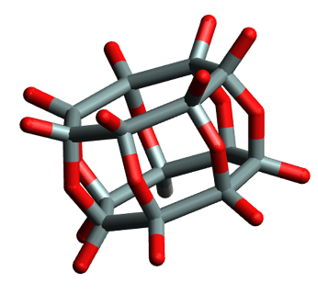

Figure 1. Caption of the figure (times new roman, 9-pts).

Table 1. Caption of the table (times new roman, 9-pts).
Catalyst | Parameter 1ª | Parameter 2^{b}
A | Data 1 | Data 2
X | Data 3 | Data 4
ª Table footnote 1 (italicized, times new roman, 9-pts)
^{b} Table footnote 2 (italicized, times new roman, 9-pts)

References
[1] A. B. Author, C. D. Author, D. E. Author, Abbreviated Journal Name Year, volume, page.

